“You better BOOK it, to get this done on time.”
EQ: How can we get creative with books?
Procedure:
- Pick a theme
- Generate some ideas on a blank sheet of paper.
- Use your best judgment and get busy.
To help, here are some examples. Google a few there are plenty more.
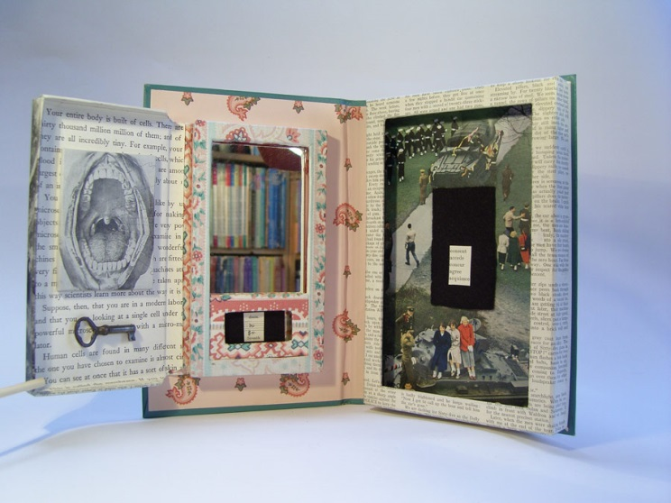
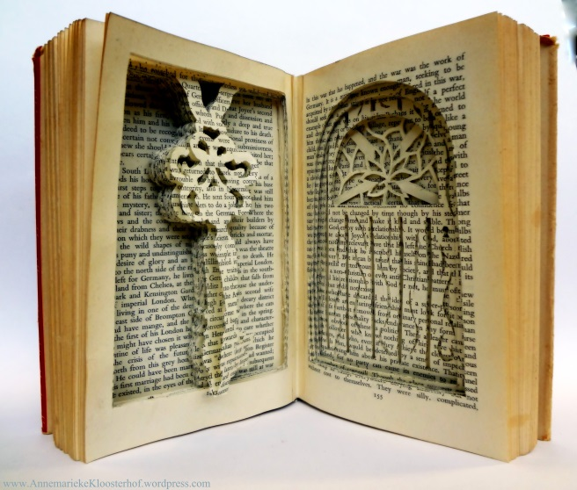

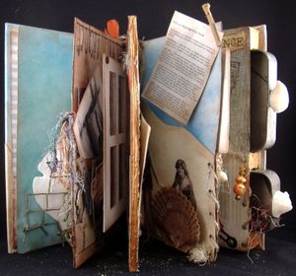

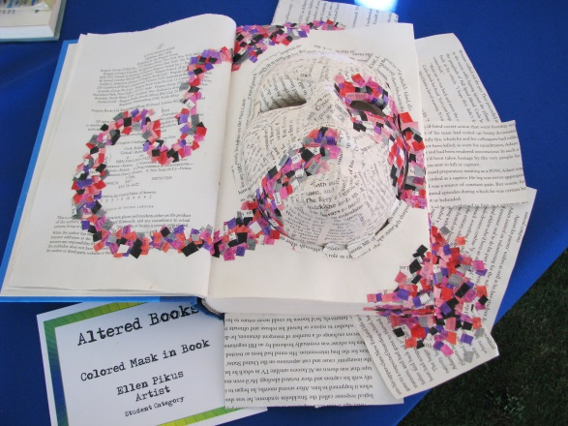
GPS: VA8C.1 Applies information from other disciplines to enhance the understanding and production of artworks.

